3GPP TSG RAN WG1 #125 R1-2604755
Dalian, China, May. 18th ~ 22nd, 2026

Source: NTT DOCOMO, INC.
Title: Discussion on Waveform and frame structure for ISAC
Agenda Item: 10.8.3
Document for: Discussion and Decision

Introduction
Based on the draft agenda, the following aspects for 6GR should be discussed in this agenda item.
    - Waveform and frame structure
Note 1: Including proposals for potential enhancement based on communication waveform (e.g., low PAPR waveform enhancement, longer CP length, larger SCS etc.), potential new waveform, frame structure, and corresponding analysis on performance benefit and impact in terms of integration with communication.
In this contribution, we first discuss the ISAC waveform design in Section 2. Secondly, the evaluation methods for ISAC waveform are analyzed in Section 3. Thirdly, the ISAC frame structure design is discussed in Section 4. Lastly, this contribution is summarized in Section 5.

ISAC waveform
In the previous RAN1#124bis, communication waveform CP-OFDM was agreed as the starting point for 6G ISAC waveform, and enhancements on CP-OFDM and/or new waveforms could be further studied.
Agreement:
CP-OFDM waveform as defined for 6GR is the starting point for 6G ISAC waveform study.
Study on enhancements on CP-OFDM or other waveforms is not precluded.

ISAC waveform baseline
Based on the communication waveform study in AI 10.2.1, for DL communication, CP-OFDM waveform as defined in 5G NR is supported as the basis. For UL communication, CP-OFDM and DFT-s-OFDM waveforms as defined in 5G NR are supported as the basis.
In the revised SID for 6GR [1], the following 6G study objectives are listed:
- Single technology framework based on a stand-alone architecture (Note1) to support the agreed existing and new services, and to satisfy the usage scenarios, requirements, deployment scenarios and design principles with acceptable performance/complexity trade-off, as determined by the RAN requirements in [RP-250810] and [TR38.914], including: [RAN1], [RAN2], [RAN3], [RAN4]
  - Ensuring appropriate set of functionalities, minimize the adoption of multiple options for the same functionality, avoid excessive configurations, excessive UE capabilities and UE capabilities reporting.
  - Energy efficiency and energy saving: both for network and device.
  - Enhanced spectral efficiency.
  - Enhanced overall coverage, focus on cell-edge performance and UL coverage.
  - Wider channel bandwidth (at least 200MHz) support for 6G deployments at least above 2 GHz, around 7 GHz.
  - Re-use of existing 5G mid-band (~3.5GHz) site grid for 6G deployments in at least around 7 GHz and targeting comparable coverage to 5G mid-band.
  - Target scalable and forward compatible design for diverse device types.
  - Improved spectrum utilization and operations taking into account diverse spectrum allocations.
  - Aim at using common 6G Radio design, which meets mobile broadband service requirements as high priority, to also meet vertical needs.
  - Aim at a harmonized 6G Radio design for TN and NTN, including their integration.
  - System simplification, including reducing configuration complexity, enabling more efficient Cell/UE management, etc.
Note1: the term stand-alone architecture does not imply any particular Core network architecture, which is up to SA2 discussion.
To satisfy the single technology framework requirement, unified waveform design for sensing and communication is required. The communication waveforms CP-OFDM and DFT-s-OFDM should be the baseline for sensing.

ISAC waveform analysis related to sensing modes
Different sensing waveforms could be considered based on different sensing modes, as summarized in Table 1.
Table 1. Sensing waveform consideration for different sensing modes
Sensing mode | Design target | views
Study unified waveform for sensing and communication: communication waveform CP-OFDM and DFT-s-OFDM should be the baseline
TRP-UE bistatic sensing | Sensing performance requirement | CP-OFDM with sensing RS pattern/sequence design
UE-TRP bistatic sensing | Sensing performance requirement | CP-OFDM/DFT-s-OFDM (and enhancements) with sensing RS pattern/sequence design
TRP/UE monostatic sensing | Sensing coverage | Study whether/how to introduce the dedicated sensing waveform
TRP-TRP bistatic sensing | Sensing coverage | Study whether/how to introduce the dedicated sensing waveform
For TRP-UE and UE-TRP bistatic sensing modes, communication waveforms CP-OFDM and DFT-s-OFDM can be reused. The main point could be how to design sensing RS sequences to satisfy the sensing performance requirements.
For TRP/UE monostatic sensing and TRP-TRP bistatic sensing modes, in addition to reusing the communication waveform, the dedicated sensing waveform could be further studied. In 5G-A ISAC, sensing waveform is up to implementation. In 6G ISAC, the dedicated sensing waveform could be specified due to waveform with standardizations enables precise interference measurement and coordination. Furthermore, it is better to deal with a known interference than an unknown one for interference management. Considering full-duplex limitation and/or the longer transmission path than communication, sensing coverage could be the main limitation for sensing. Therefore, dedicated sensing waveform with more extensive coverage could be designed.
Dedicated sensing waveform should be based on the OFDM framework, due to the common framework aligned with the baseline communication waveform can be beneficial for sensing resource acquisition, interference and coexistence handling, and multiplexing of sensing symbols, etc. A dedicated sensing waveform could be designed to improve sensing capability in coverage and/or weak-target scenarios. For example, chirp signal with OFDM-compatibility with low peak-to-average power ratio (PAPR) and Peak-to-Side Lobe Ratio (PSLR), and/or pulse-waveform (PW) with OFDM-compatibility with low PAPR and self-interference resilience.
Observation 1: For TRP/UE monostatic and TRP-TRP bistatic sensing modes, sensing-dedicated waveform with OFDM-compatibility could be studied to improve sensing capability in coverage and/or weak-target scenarios.
Proposal 1: Study unified OFDM-based waveform for sensing and communication, including waveforms for TRP/UE monostatic and TRP-TRP bistatic sensing
- Communication waveform CP-OFDM and DFT-s-OFDM should be the baseline for sensing
- Study sensing-dedicated waveform with OFDM-compatibility to improve sensing capability in coverage and/or weak-target scenarios

Reuse communication waveforms with the RS sequence for sensing
In 5G NR, gold sequence (or pseudo-random, PN sequence) is supported for RS sequence generation in both uplink and downlink. For downlink RS, QPSK is considered as the modulation scheme of PN and QPSK modulated PN sequence is transmitted with CP-OFDM, e.g., DMRS in PDSCH, CSI-RS and TRS. For uplink RS with extremely low PAPR, pi/2-BPSK is considered as the modulation scheme of PN and DFT is applied to generate the final RS sequence. This indicates that pi/2-BPSK modulated PN sequence is transmitted with DFT-s-OFDM, e.g., DMRS in PUSCH with DFT-s-OFDM and pi/2-BPSK modulation. In addition, Zadoff-Chu (ZC) is supported for RS sequence in uplink due to its low PAPR and good auto-/cross-correlation features, e.g., DMRS in PUSCH with DFT-s-OFDM, SRS, preamble sequence, etc. 30 root indices of ZC are uniformly selected from all candidates $1≤q≤N_{ZC}-1$ for ZC with prime length $N_{ZC}$.
PN/ZC sequences of communication RS mainly focus on the communication performance metric, e.g., PAPR, sequence number and auto-/cross-correlation, etc. For sensing RS, sensing performance should be considered during the sequence design, e.g., ambiguity function and related metrics including PSLR and/or integrated sidelobe ratio (ISLR), etc. We show that modulation scheme would affect the power of sidelobes of PN sequences as shown in Figure 2-1 and the root index would affect the power of sidelobes of ZC sequences as shown in Figure 2-2. Furthermore, to validate the impacts on communication performance, we evaluate the BLER performance of proposed PN/ZC sequences. Results in Figure 2-3 show that proposed PN/ZC sequences have no impacts of channel estimation performance and are suitable for the enhanced communication RS for sensing or dedicated sensing RS.
Observation 2: pi/2-BPSK modulated PN sequences and ZC sequence based on non-uniformly selected root index could improve sensing performance without affecting communication performance.
Based on these observations, two enhancements of PN/ZC could be further studied for sensing RS sequences.
- Modulation scheme of PN sequences
- Root index of ZC sequences
Proposal 2: Study the modulation scheme of PN and the root index of ZC for RS sequence for sensing.
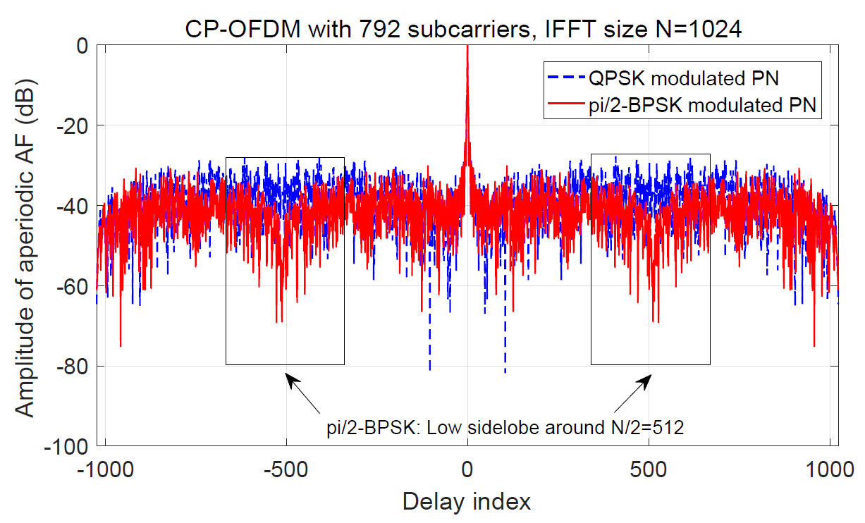 | 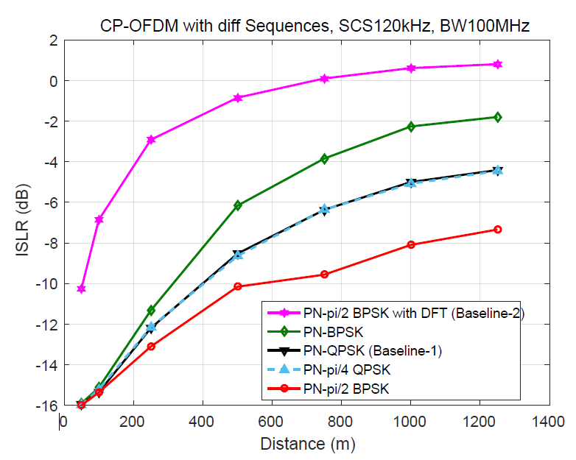
- Amplitude of aperiodic ambiguity function of PN | - ISLR of different modulation schemes for PN
Figure 2-1 Impacts of modulation scheme of PN sequences on sensing performance
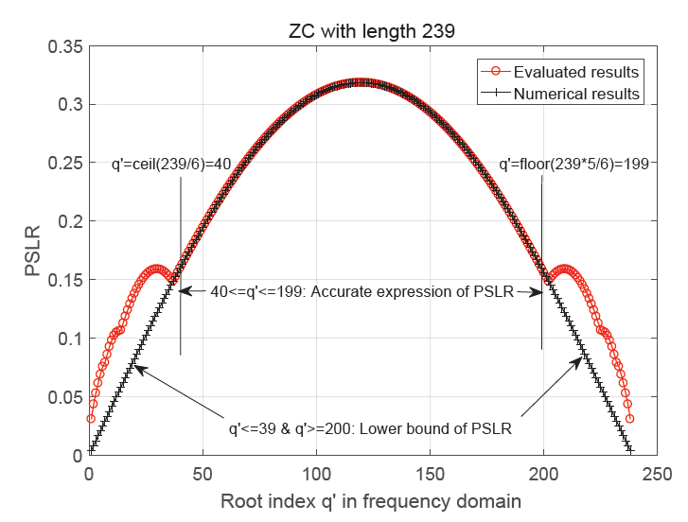 | Before (NR uniform selection):  After (Proposed non-uniform selection):  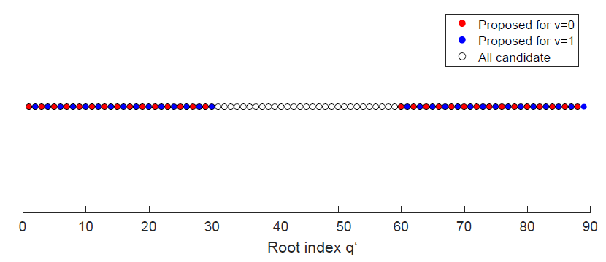 | 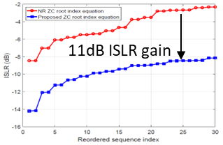
- Relationship between ZC root index and PSLR | - Root index selection | - ISLR comparison of proposed ZC and NR ZC
Figure 2-2 Impacts of root index of ZC sequences on sensing and communication performance
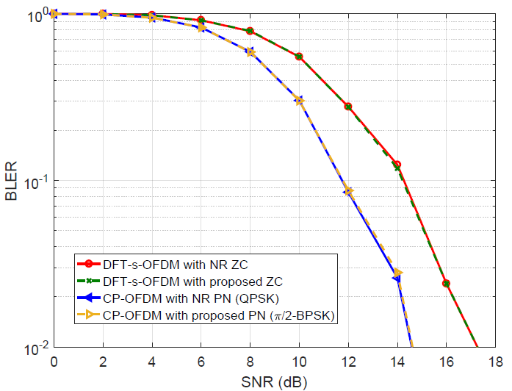
No impacts on BLER performance
Figure 2-3 Communication performance comparison of proposed PN and ZC sequence

Dedicated sensing waveform based on CP-OFDM enhancement

Chirp signal based on CP-OFDM enhancement
The chirp signal is one of the most commonly used waveforms in radar systems. It has advantages in low PAPR and PSLR/ISLR to improve sensing capability in coverage and/or weak-target scenarios.
An OFDM-compatible chirp signal generation method was proposed in [2]. Chirp signal for sensing can be generated by adding a frequency-domain processing module (DFT + spreading) before the IFFT in the OFDM transmitter, as shown in Figure 2-4(a). Furthermore, by designing the chirp index sequence pattern, one and/or multiple orthogonal chirps can be generated to achieve a trade-off between PAPR and multiplexing flexibility. Examples for two different chirp index sequence patterns and the corresponding chirp signals are given in Figure 2-4(b).
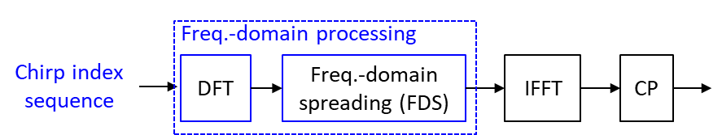
- Chirp signal generation based on OFDM transmitter
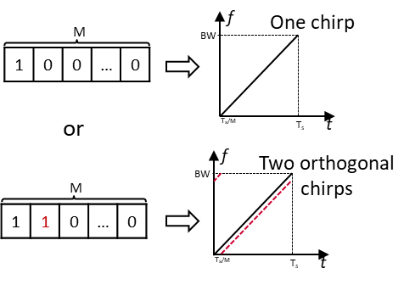
- Chirp index sequence patterns and corresponding chirp signal
Figure 2-4 Chirp signal based on OFDM transmitter
The ambiguity function and PAPR performance of the proposed chirp signal are evaluated and compared with CP-OFDM based on the ZC RS sequence, as shown in Figure 2-5. It can be found that the proposed chirp signal can achieve both PAPR and lower ambiguity function sidelobe (PSLR/ISLR) than CP-OFDM with ZC sequence.
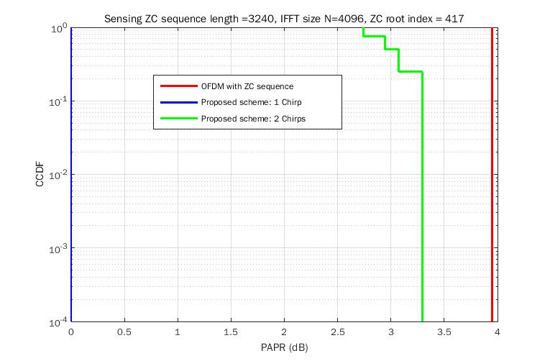  - PAPR performance | 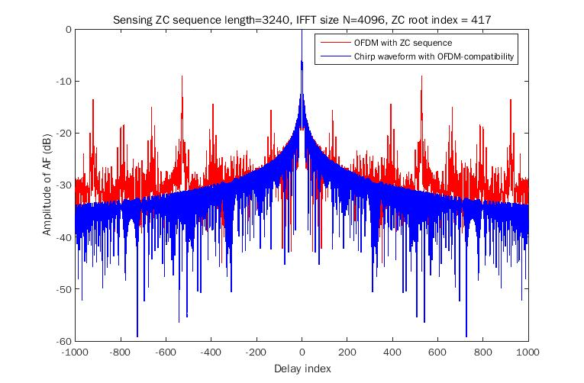  (b)Amplitude of ambiguity function
Figure 2-5 PAPR and ambiguity function of the proposed chirp signal
Observation 3: Chirp waveform/signal can be generated based on the OFDM transmitter to reduce PAPR and PSLR

Pulse waveform based on CP-OFDM enhancement
Pulse waveform/signal is widely adopted for the trials of NR UAV sensing due to the pulse waveform/signal enabling the TDD-based TRP/UE monostatic sensing mode to avoid self-interference, and a larger transmit power can be used to improve the sensing coverage.
Pulse waveform/signal can be generated based on the OFDM transmitter by performing the DFT transform on the sensing sequence before the IFFT, as shown in Figure 2-6. Furthermore, by designing the sensing sequence pattern, different number of pulses can be generated within one OFDM symbol. For example, one pulse can be generated by the sensing sequence with a localized pattern, and two pulses can be generated by the sensing sequence with a distributed pattern, as shown in Figure 2-5.
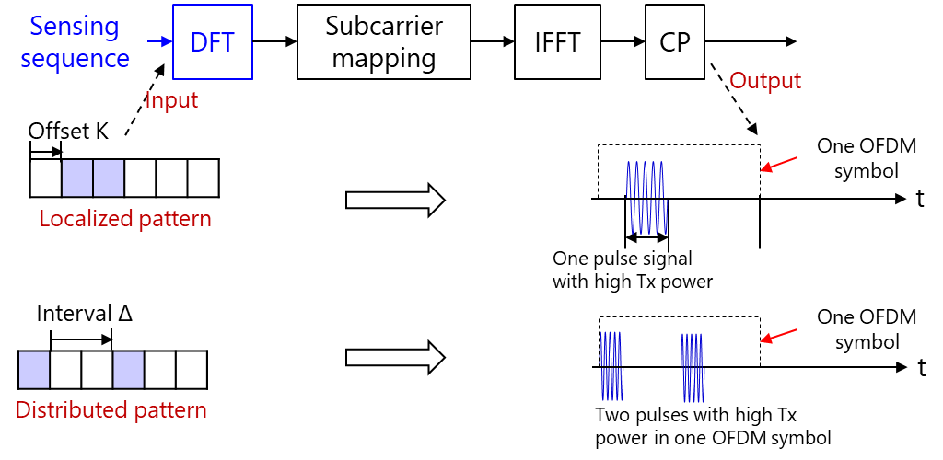
Figure 2-6 Pulse waveform based on OFDM transmitter

Observation 4: Pulse waveform/signal can be generated based on the OFDM transmitter to improve sensing coverage
Proposal 3: Study the chirp and/or pulse waveform/signal based on the OFDM transmitter for sensing-dedicated waveform.

ISAC waveform evaluation
In the previous RAN1#124bis, the following agreements were made for ISAC waveform evaluation. CP-OFDM is used as the benchmark for sensing waveform evaluation, and companies are encouraged to provide their views on the necessity/pros/cons/metrics of LLS and/or SLS, and pros/cons/metrics of theoretical waveform characteristics analysis
Agreement:
Companies are encouraged to provide views on necessity/pros/cons/metrics of LLS and/or SLS and pros/cons/metrics of theoretical waveform characteristics analysis, for evaluation of ISAC waveform and/or integration with communication, to RAN1#125 meeting.
Agreement:
CP-OFDM is used as the benchmark for evaluating the benefits of sensing waveforms.
We analyse the three evaluation methods and their corresponding metrics below:
- Theoretical waveform characteristics analysis
  - For the ISAC waveform study, the currently identified metrics are PAPR and ambiguity function-related metrics, e.g., PSLR, ISLR, and 3dB main lobe width, which can be sufficiently evaluated based on the theoretical waveform characteristics analysis.
  - Metric: PAPR and ambiguity function-related metrics, e.g., PSLR, ISLR, and 3dB main lobe width
- LLS
  - Currently, no specific use cases requiring LLS have been identified for the waveform study. Furthermore, a dedicated LLS channel model for sensing is not yet available. However, if further study indicates that LLS is necessary, the first step would be to develop an LLS channel model for sensing, followed by simulations to evaluate performance based on the following metrics.
  - Metric: Range and velocity accuracy
- SLS
  - Currently, no specific use cases or scenarios requiring SLS have been identified for the waveform study. Furthermore, SLS performance is not determined solely by the waveform itself; it is also significantly influenced by the specific channel and environmental conditions, which makes isolating the pure waveform performance challenging. However, if further study indicates that SLS is necessary, we will need to conduct simulations for performance comparison based on the following metrics.
  - Metric: Miss detection probability, False alarm probability, Horizontal/Vertical positioning accuracy, Velocity accuracy, etc.
The following proposal can be concluded based on the analysis:
Proposal 4: Waveform characteristics analysis focuses on metrics of PAPR and ambiguity function-related metrics (e.g., PSLR, ISLR, and 3dB main lobe width) could be the first step for sensing waveform evaluation.
- Study whether/how to perform LLS and/or SLS evaluations for the sensing waveform study.

ISAC frame structure
In the previous RAN1#124bis, the 6GR communication frame structure (including the aspects of frame/sub-frame/slot/symbol structure, CP length, and SCS) as the starting point for 6G ISAC frame structure study was agreed. And the enhancements for the above aspects are not precluded.
Agreement:
6GR communication frame structure is the starting point for 6G ISAC frame structure study, in at least the following aspects.
- Frame/sub-frame/slot/symbol structure
- CP length
- SCS
Enhancements on frame structure/above aspects are not precluded.

Frame structure design
Whether a unified frame structure design for sensing and communication, or a dedicated sensing/ISAC frame structure to be introduced, needs to be discussed. When the communication RS is reused for sensing, unified frame structure design can be applied for communication and sensing.
However, when TDMed resource multiplexing for sensing and communication is applied, whether to introduce dedicated sensing/ISAC frame structure design can be further studied. For example, for some sensing modes (e.g., TRP monostatic sensing or TRP-to-TRP bistatic sensing), CP length may need to be extended for sensing to cover larger target delay spreads.
Observation 5: CP length may need to be extended for sensing to cover larger target delay spreads for some scenarios/sensing modes

CP length extension
If CP length extension is considered for sensing, at least symbol and/or slot-level alignment between communication and sensing/ISAC should be maintained to enable efficient multiplexing between communication and sensing.
- Symbol-level alignment
Symbol-level alignment between sensing and communication symbols means that the total length of one symbol (i.e., one OFDM symbol length + CP length) and the number of symbols per slot remain the same for both sensing and communication. To achieve a longer CP length for sensing with given length of one symbol, the length of one OFDM symbol can be decreased by considering a larger subcarrier spacing and/or compressed/truncated based on the communication FFT size. Symbol/sub-slot/slot-level multiplexing between sensing and communication can be supported for symbol-level alignment.
An example of the sensing/ISAC slot with CP length extension based on symbol-level alignment is shown in Figure 4-1.
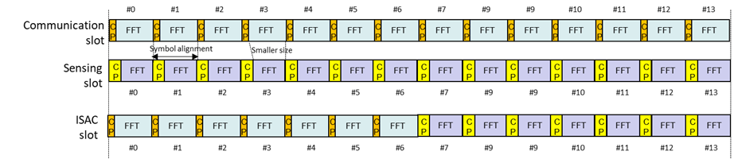
Figure 4-1 CP length extension based on symbol-level alignment between sensing and communication symbols
- Slot-level alignment
Slot-level alignment between sensing and communication means that the slot length remains the same for both sensing and communication. To extend the CP length for sensing symbols, the concept of the extended CP (ECP) in 5G NR can be adopted, i.e., reducing the number of sensing symbols per slot while keeping the FFT size the same for both sensing and communication. With slot-level alignment, only sub-slot or slot-level multiplexing between sensing and communication can be supported.
An example of sensing/ISAC slot with the CP length extension based on slot-level alignment is shown in Figure 4-2.
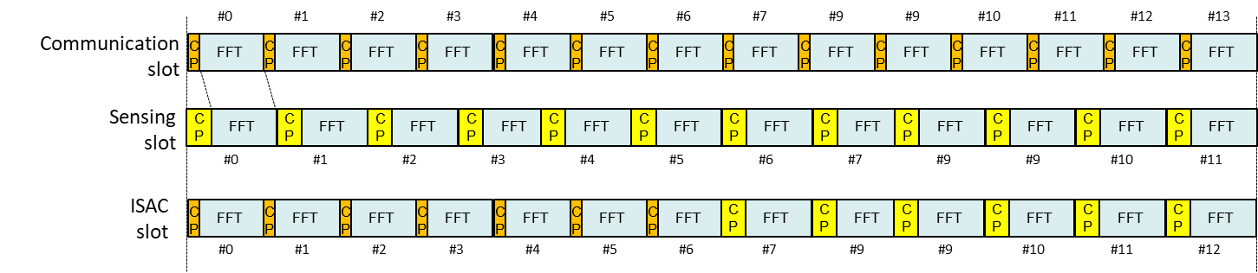
Figure 4-2 CP length extension based on slot-level alignment between sensing and communication slots

Observation 6: CP length extension for sensing can be achieved based on both symbol-level and slot-level alignment between sensing and communication symbols and slots, respectively.
Proposal 5: Study whether to introduce dedicated sensing frame structure design (e.g., SCS and/or CP and/or slot/sub-frame/frame length)
- If a dedicated sensing frame structure with CP length extension is considered, at least symbol and/or slot-level alignment between communication and sensing/ISAC symbols and/or slots should be maintained.

Frame structure configuration
Whether to introduce dedicated sensing slot/sub-frame/frame configuration needs to be discussed. When communication RS is reused for sensing, dedicated sensing slot/sub-frame/frame configuration is not needed.
However, when TDMed resource multiplexing for sensing and communication is applied, if unified SCS/CP/slot/sub-frame/frame length for sensing and communication is applied, the necessity of dedicated sensing slot/sub-frame/frame configuration can be further discussed. For example, if the sensing traffic/task tends to be periodic/predictable, dedicated sensing slot pattern can help to reduce sensing/communication collision handling complexity. If dedicated slot/CP/SCS design for sensing is introduced, configuration of dedicated sensing slot/frame is needed.

Proposal 6: Study the necessity of dedicated sensing slot/sub-frame/frame configuration.

Conclusion
In this contribution, we present our general views on the ISAC waveform design, ISAC waveform evaluation, and ISAC frame structure design for the 6GR. The following observations and proposals are made based on the discussion.
Observation 1: For TRP/UE monostatic and TRP-TRP bistatic sensing modes, sensing-dedicated waveform with OFDM-compatibility could be studied to improve sensing capability in coverage and/or weak-target scenarios.
Observation 2: pi/2-BPSK modulated PN sequences and ZC sequence based on non-uniformly selected root index could improve sensing performance without affecting communication performance.
Observation 3: Chirp waveform/signal can be generated based on the OFDM transmitter to reduce PAPR and PSLR
Observation 4: Pulse waveform/signal can be generated based on the OFDM transmitter to improve sensing coverage
Observation 5: CP length may need to be extended for sensing to cover larger target delay spreads for some scenarios/sensing modes
Observation 6: CP length extension for sensing can be achieved based on both symbol-level and slot-level alignment between sensing and communication symbols and slots, respectively.

Proposal 1: Study unified OFDM-based waveform for sensing and communication, including waveforms for TRP/UE monostatic and TRP-TRP bistatic sensing
- Communication waveform CP-OFDM and DFT-s-OFDM should be the baseline for sensing
- Study sensing-dedicated waveform with OFDM-compatibility to improve sensing capability in coverage and/or weak-target scenarios
Proposal 2: Study the modulation scheme of PN and the root index of ZC for sensing-dedicated RS sequence.
Proposal 3: Study the chirp and/or pulse waveform/signal based on the OFDM transmitter for sensing-dedicated waveform.
Proposal 4: Waveform characteristics analysis focuses on metrics of PAPR and ambiguity function-related metrics (e.g., PSLR, ISLR, and 3dB main lobe width) could be the first step for sensing waveform evaluation.
- Study whether/how to perform LLS and/or SLS evaluations for the sensing waveform study.
Proposal 5: Study whether to introduce dedicated sensing frame structure design (e.g., SCS and/or CP and/or slot/sub-frame/frame length)
- If a dedicated sensing frame structure with CP length extension is considered, at least symbol and/or slot-level alignment between communication and sensing/ISAC symbols and/or slots should be maintained.
Proposal 6: Study the necessity of dedicated sensing slot/sub-frame/frame configuration.

Reference
- 3GPP, RP-253876, NTT DOCOMO, INC, CMCC, AT&T, Vodafone, “Revised SID: Study on 6G Radio”, Dec. 2025.
- J. Liu, W. Liu, X. Hou and L. Chen, "An OFDM Compatible Sensing Waveform Design for 6G ISAC System," 2024 IEEE 29th Asia Pacific Conference on Communications (APCC), BALI, Indonesia, 2024, pp. 71-76,

